Day -4 Assignment
1. Open your own laptop or desktop (or use an online PC hardware simulator if you don't have access to a real system) and identify the GPU model installed. Write down the GPU's brand, model number, and whether it is integrated or dedicated.
Item | Details
GPU Brand | Intel
GPU Model Number | Intel UHD Graphics
Type | Integrated GPU

2. Take a clear photo or screenshot of the cooling system (fan, heatsink, or liquid cooling setup) inside your PC or from a PC hardware simulator. Label the main cooling components and briefly describe their function.
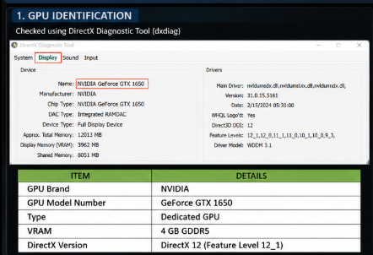
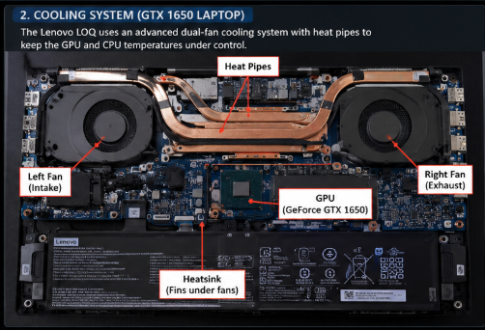
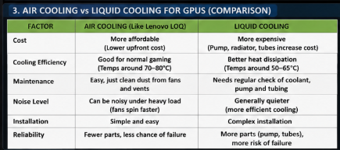

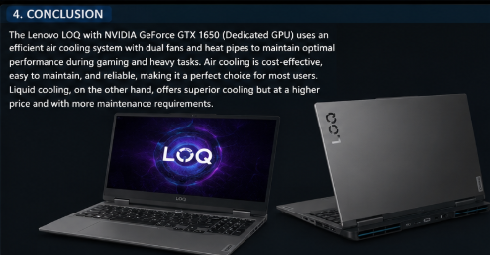

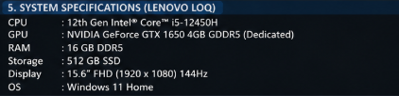

Component | Function
CPU Fan | Spins to move hot air away from the CPU heatsink.
Heatsink | Absorbs heat from the CPU and transfers it to the surrounding air.
Case Fan (Front Intake) | Pulls cool air into the PC case.
Case Fan (Rear Exhaust) | Pushes hot air out of the PC case.
Thermal Paste | Improves heat transfer between the CPU and heatsink.

Brief Description
- CPU Fan – Mounted on top of the heatsink and cools the processor by blowing air through the heatsink fins.
- Heatsink – Made of aluminum or copper; it absorbs and dissipates heat generated by the CPU.
- Front Intake Fan – Brings cool air from outside the case into the system.
- Rear Exhaust Fan – Removes hot air from inside the case.
- Thermal Paste – Fills tiny gaps between the CPU and heatsink to improve cooling efficiency.

3. Create a comparison table listing at least 3 differences between air cooling and liquid cooling systems for GPUs, including factors like cost, efficiency, and maintenance.
Factor | Air Cooling | Liquid Cooling
Cost | Less expensive and budget-friendly. | More expensive due to pumps, radiators, and tubing.
Cooling Efficiency | Good for normal gaming and everyday use. | Better cooling performance, especially for high-end GPUs and overclocking.
Maintenance | Requires occasional dust cleaning only. | Requires monitoring of coolant, tubing, and pump; more maintenance.
Installation | Easy to install and replace. | More complex installation process.
Noise Level | Can be louder under heavy load because fans spin faster. | Usually quieter since heat is dissipated more efficiently.
Size Requirements | Takes up less space and fits most PC cases. | Needs additional space for radiator and tubing.
Reliability | Fewer components, so there is less chance of failure. | More components (pump, tubes) mean more potential points of failure.

4. Imagine you are building a gaming PC for streaming IPL matches and playing graphics-heavy games. Choose between air cooling and liquid cooling for your GPU, and justify your choice in 3-4 sentences based on your research.
Choice: Air Cooling for NVIDIA GeForce GTX 1650
If I were building a gaming PC for streaming IPL matches and playing graphics-heavy games, I would choose air cooling for the NVIDIA GeForce GTX 1650 GPU. The GTX 1650 is a mid-range graphics card that does not produce excessive heat, so a good air-cooling system is sufficient to keep temperatures under control.
Air cooling is more affordable, easier to install, and requires very little maintenance compared to liquid cooling. It also provides reliable performance for gaming and streaming without the added cost and complexity of pumps, radiators, and coolant. Therefore, air cooling offers the best balance of performance, cost, and reliability for a GTX 1650-based gaming PC.

